**Prairie and Tree Planting Tool (PT2 1.0) - Iowa Version**

**Documentation of Features and Data**

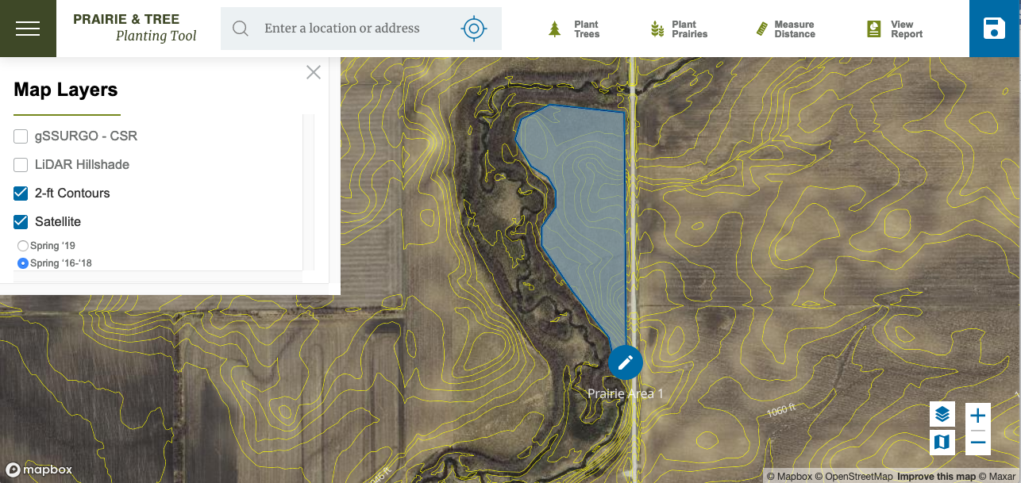

**Available @:** [**https://pt2.nrem.iastate.edu/**](https://pt2.nrem.iastate.edu/)

**Funded by**

Foundation for Food and Agriculture Research -

Impact of Prairie on Reducing Interacting Stressors on Pollinator Health.

(Project # 549025); USDA McIntire-Stennis Program (project numbers IOW5354, IOW5534); and North Central Regional Sun Grant Center/USDA-NIFA competitive grants program (Grant No. ID0EYKAE1454)

Primary Contact: John Tyndall, Iowa State University, [jtyndall@iastate.edu](mailto:jtyndall@iastate.edu)

**Index**

**Prairie and Tree Planting Tool (PT2 1.0) Iowa Version – Overview................. 2**

**Why plant trees or prairie? ................................................................................ 2**

**PT2 1.0 Features & Use ...................................................................................... 3**

**Data and Data Sources ..................................................................................... 3**

**Financial Analysis Methods and Data .............................................................. 4**

**Table 1**: Transaction table that displays expected establishment and management actions, and estimated range of costs for a prairie system 5

**Table 2**: Transaction table that displays expected establishment and management actions, and estimated range of costs for planting trees (in 2020 dollars). 6

**Opportunity Costs of Land ............................................................................... 6**

**Tree, Shrub, and Prairie Seed Mix Costs ....................................................... 8**

**Conservation program parameters and payment schedules for 2020 ......... 10**

**About the software ........................................................................................... 12**

**Appendix: Soil productivity and land rent data for Iowa .............................. 14**

**References ......................................................................................................... 16**

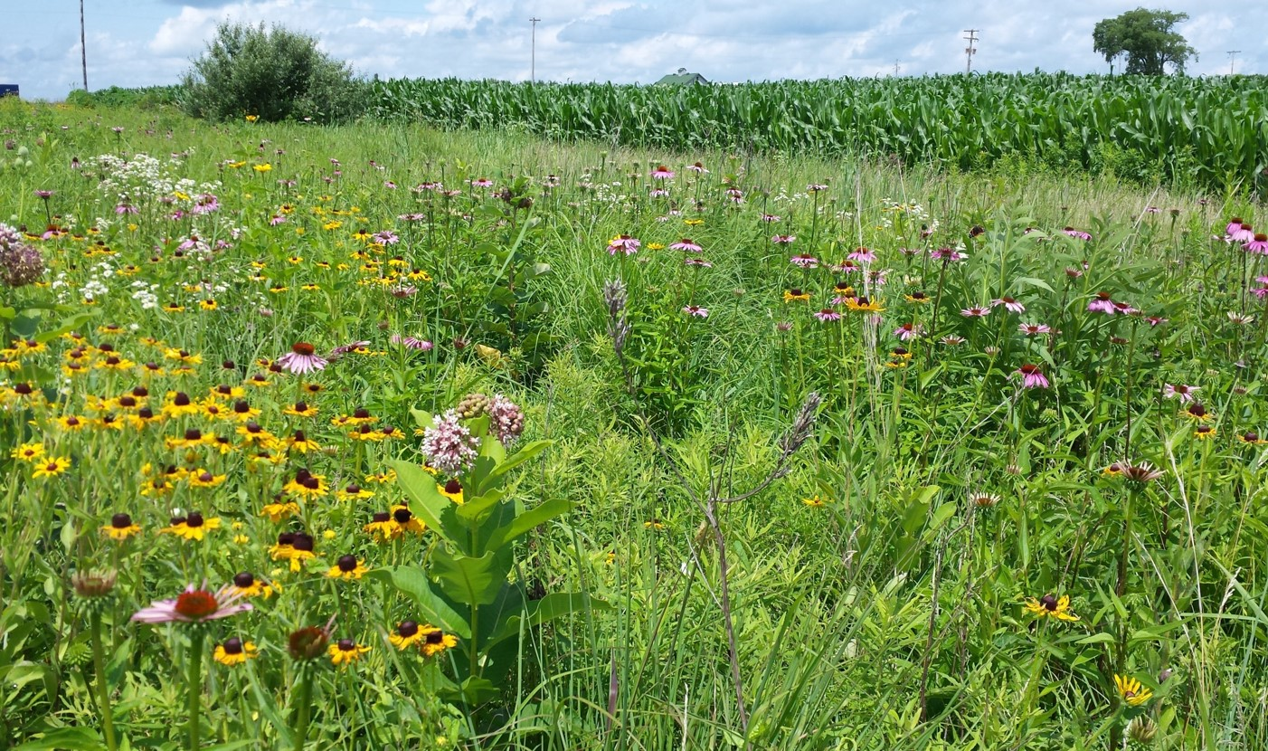

**Pollinator habitat next to corn field. Image: Illinois NRCS**

**Prairie and Tree Planting Tool (PT2 1.0) Iowa Version.**

**Overview** This document overviews the Prairie and Tree Planting Tool (PT2 1.0), an online decision support tool for landowners interested in exploring opportunities to plant trees and or prairie in or around their farm fields. The Prairie & Tree Planting Tool (PT2 1.0) can be found online at:<https://pt2.nrem.iastate.edu/>. With the PT2 (1.0) users locate their farms or properties of interest in an online high resolution aerial photo and mapping geographic information system (GIS) that uses a <https://www.mapbox.com> interface. Users then can explore areas that they might consider for tree or prairie cover by examining different data layers: aerial photos flown at different times of the year, soil maps, 2-foot contour topography maps, LiDAR hillshade images (hillshade images are high resolution black-and-white images showing elevation changes in the landscape), and a map of current land values (based on estimated land rent). Users then utilize scaled dimensional drawing tools to measure and delineate areas of interest for planting trees and or prairie. Once an area of interest is delineated, users can select from drop down menus tree/shrub species or prairie seed mixes that are suitable for the soils present, and users can select basic long-term management options. Once a planting design is determined, PT2 : 1.0 estimates total annualized costs for tree or prairie establishment, long-term management, and opportunity costs (based on area weighted expected soil rent), and factors in the potential benefit of utilizing relevant government cost-share programming, e.g., Environmental Quality Incentive Program (EQIP) or the Conservation Reserve Program (CRP). For prairie systems that are being used as pollinator habitat, a pest management “buffer area” surrounding the prairie is often recommended to protect pollinators from chemical drift. As such, PT2 1.0 calculates a 50-foot “buffer area” surrounding all prairie that a user may designate as pollinator habitat. This area data in turn can be used as input data for the parallel spreadsheet based decision support tool (PT2 - IPM) that allows users to select various Integrated Pest Management (IPM) options relative to a designated buffer area so as to determine total field costs of not just the pollinator habitat, but also all ancillary management changes relative to adjacent cash crops (e.g., costs of IPM).

**Why plant trees or prairie?** Land owners may be interested in exploring opportunities to diversify the land cover on their farmland by integrating/ incorporating trees or prairie. There are many conservation oriented practices that are based on trees or prairie cover. Likewise, both of these perennial vegetation systems have distinct production opportunities in Iowa particularly for biomass for bioenergy or fodder/bedding. Trees are planted in agricultural landscapes for windbreaks and shelterbelts that are used to minimize wind erosion and protect fields, buildings, and livestock, or as forest buffers used to minimize pollen drift or to protect riparian areas from field runoff (Brandle et al., 2009; Groh et al., 2020 ). Prairie systems are important as habitat for pollinators, game and non-game wildlife particularly grassland bird species (Schulte et al., 2016). Strategically located prairie systems planted as strips of vegetation on the contours and toeslopes of crop fields (known simply as prairie strips) are increasingly being utilized in Iowa and other states as a water quality best management practice that intercepts and slows runoff, increases infield infiltration and water storage, with the combined effect of significantly reducing field-level nutrient and soil loss (Schulte et al., 2017). See the Iowa State University Prairie Strips research and outreach site: <https://www.nrem.iastate.edu/research/STRIPS/>.

There are numerous state and Federal conservation programs that provide both technical and financial support to landowners interested in planting trees and or prairie for conservation purposes. It is highly recommended that landowners interested in these opportunities contact their [local Natural Resource Conservation Service center](https://www.nrcs.usda.gov/wps/portal/nrcs/main/national/contact/local/).

**PT2 1.0** **Features & Use** The PT2 1.0 features an online GIS interface with Google map based address search capabilities, or users can navigate via zoom features. While PT2 1.0 can navigate to anywhere in the United States, most of the data layers re functional only in Iowa, likewise the financial data is specific to Iowa. Later versions of PT2 1.0 will feature other states. In its current form, users can select if they want to use the 1) tree planting design application, or the 2) prairie planting design application. Users can select with drop down menus different data layer options they wish to use to explore planting opportunities. The tree planting tool allows users to select an area of interest for planting trees using a linear selection tool. PT2 1.0 then will arrange the desired number of rows of trees (representing idealized planting design for windbreaks or plantations), users select from a menu of species suitable for the soil conditions, and select from a general list of land use goals (e.g., windbreak, other). Likewise, for the prairie design application, users select an area of interest using a polygon drawing tool. Users can select from a menu a pre-made seed mixes suitable for the soils present (or enter the price of mix of their own). Users then select the likely general long-term management (mowing or burning). For both design tools, once the tree or prairie system of interest is in place, PT2 1.0 will calculate and present the estimated direct and opportunity costs of the planting (breaking costs down into the following categories: 1) site preparation, 2) establishment, 3) management, and 4) opportunity costs. For tree plantings, users can see the financial effects of utilizing the [2020 Iowa EQIP program](https://www.nrcs.usda.gov/wps/portal/nrcs/ia/programs/financial/eqip/) for establishing windbreak systems (Practice Codes 490-site preparation, 612 tree/shrub establishment, 380 windbreak tree stock). For prairie systems, users can see the financial effects of utilizing the 2019 Iowa Conservation Reserve Program for [CP 42 Pollinator Habitat](https://www.fsa.usda.gov/Assets/USDA-FSA-Public/usdafiles/FactSheets/2019/crp_continuous_enrollment_period-fact_sheet.pdf) or [CP 43 Prairie Strips](https://www.fsa.usda.gov/Assets/USDA-FSA-Public/usdafiles/FactSheets/2019/crp_clear_initiative_prairie_strip_practice-fact_sheet.pdf). Users can save designs and download them into ArcGIS for additional GIS modeling.

**Data and Data Sources** There are several primary data layers that singularly or in combination can help landowners and their advisors explore opportunities on their land for planting trees and or prairie. Topography, soil type, landscape position (e.g., hilltop/summit/ridge, shoulder slopes, backslope, toe and foot slopes), aspect, proximity to water all can provide guidance on site-level vulnerabilities to erosion, overland flow of water, and the movement of nutrients and sediment. Or to explore alternatives for low yielding crop land. The PT2 (1.0) includes different aerial orthophoto data sets, a soil map, 2-foot elevation contour layer, a LiDAR hillshade, layer, and a layer that displays the Corn Suitability Rating (CSR2) and estimated land rent value per soil type. Specific data layers include:

* [Mapbox Streets](https://www.openstreetmap.org/#map=5/38.007/-95.844) includes streets, buildings, administrative areas, water, and land data.
* Iowa 2019 USDA National Agriculture Imagery Program (NAIP) Orthophotos, captured July-October 2019: <https://ortho.gis.iastate.edu/arcgis/rest/services/ortho/naip_2019_nc/ImageServer>
* Iowa 2016-2018 Spring Orthophotos: <https://athene.gis.iastate.edu/arcgis/rest/services/ortho/ortho_2016_2018_nc/ImageServer>
* Iowa LiDAR Hillshade from 2007-2010 state-wide collection: <https://athene.gis.iastate.edu/arcgis/rest/services/ortho/lidar_hs/ImageServer>
* Two-foot elevation contour data: <https://geodata.iowa.gov/dataset/two-foot-contours-iowa-derived-lidar-data>
* NRCS SSURGO Soils web map service (soil mapping and CSR2 data layer): <https://sdmdataaccess.sc.egov.usda.gov/Spatial/SDM.wms?SERVICE=WMS&REQUEST=GetCapabilities>

**Financial Analysis Methods and Data**

Planted tree or prairie systems involve upfront establishment costs, annual and/or periodic management costs, annual land use costs (opportunity cost of land), and may involve conservation payments or revenues over time. To analyze these costs and benefits, all upfront and future costs and conservation payments are discounted to the present time (present value) so as to appropriately account for the time-value of money. The 2019 Federal nominal discount rate for water oriented land projects is 3.75% (USDA-NRCS 2013), the real discount rate is 0.69%. We chose a conservative real discount rate of 2%. Note that for production systems where a revenue is expected (e.g., from selling biomass), one might use a higher discount rate to better represent the cost of capital used in commodity production. A base discount rate of 5% represents a 10 year average real rate of return to assets on Iowa farms (Plastina 2019), and is also the typical real rate of return to capital on U.S. farms Erickson et al. (2004). The current version of PT2 (1.0) only calculates the annualized present value of costs.

For farm-level Discounted Cash Flow (DCF) cost analysis there are typically two key computational tasks: 1) calculating total present value costs of the tree or prairie planting over the relevant planning horizon; and 2) translating the total present value cost to an equal annual cost basis. For reference, the DCF computational structure is as follows:

Present Value Costs = PVC = $\sum_{t=0}^{n}{Total Costs \frac{1}{(1+{r)}^{t}}}$ [1]

Where total costs represent all costs associated with establishing and managing a BMP over a designated period of time; *r* represents the discount rate; and *t* represents the analytical time frame. Note, there may be conservation payments involved. When this is the case, such payments represent a cash inflow rather than outflow. *Equation 1* is simply modified to represent total “benefit”; present value costs are subtracted from present value benefits (net present value). The calculated total present value cost for a tree or prairie planting is then annualized by converting into an equal annual cost basis (EAC) by applying a capital recovery factor (CRF):

     CRF = $\frac{r(1+{r)}^{t}}{(1+{r)}^{t}- 1}$   [2]

     EAC = PVC * CRF [3]

Where *r* represents the discount rate; and *t* represents the analytical time frame.

The EAC format allows landowners/ farmers to consider BMP costs essentially on the same annual basis that they consider other farm-level production costs. For the PT2 1.0, enterprise budgets for tree plantings and prairie were developed using a combination of custom rates and regional dealer transaction surveys (see tables 1 and 2 for prairie and tree enterprise budgets).

**Table 1**: Transaction table that displays expected establishment and management actions, and estimated range of costs for a prairie system (in 2020 dollars). Data is updated from Tyndall et al., 2013.

|  |  |  |
| --- | --- | --- |
|  | Range of costs 1 (acres, unless otherwise labeled) | Mean price per acre |
| **Site preparation** Year: 0 | | |
| Tillage (tandem disking) | $9.00 - 23.00 | $15.50 |
| Herbicide & application | $39.75 – 49.00 | $44.37 |
| **Establishment** Years: 0-2 | | |
| Seed (year 0) | User selects | User selected seed mix. |
| Seed drilling (year 0) | $12.00 – 25.00 | $18.70 |
| Seed cultipacking (year 0) | $8.00 – 20.00 | $14.00 |
| Mowing for establishment (x3 in first and second year) | $24 – 75.00 | $50.00 |
| Mowing, raking, wind rowing, baling for establishment (once in years 1 and 2) | $24.00 – 49.00 | $36.50 |
| **Management** Years: every 2-3 years | | |
| Mowing, raking, wind rowing, baling for management (every 2-3 yrs) | $24.00 – 49.00 | $36.50 |
| OR |  |  |
| Burning | $35.00 – 124.00 (per hour) | $62.00 |
| **Opportunity and overhead costs** Years: annual | | |
| Annual land rent | PT2 1.0 calculates area weighted, CSR2-based land rent. | Calculated by PT2 1.0. |
| Annual general operating costs | ~ 3% of establishment costs | $10 |

(1) The PT2 1.0 tool uses mean prices as defaults for the financial assessment of prairie systems; seed costs are a function of user seed mix selection.

**Table 2**: Transaction table that displays expected establishment and management actions, and estimated range of costs for planting trees (in 2020 dollars). Data is adapted and updated from Manatt et al., 2013.

|  |  |  |
| --- | --- | --- |
|  | Range of costs (acres, unless otherwise labeled) | Mean cost per acre (1) |
| **Site preparation** Year: 0 | | |
| Tillage (tandem disking only if planting into crop field) | $9.00 - 23.00 | $16.00 |
| Tillage (chisel plow and tandem disking if planting into pasture) | $23.00 – 45.00 | $35.50 |
| Herbicide & application | $39.75 – 49.00 | $44.37 |
| **Establishment** Year: 0 | | |
| Princep (pre-emergent herbicide) | $3.75/ pint | $7.50 |
| Goal (pre-emergent herbicide) | $8.90/ pint | $8.90 |
| Stinger (post-emergent herbicide) | $59.54/ pint | $39.30 |
| Poast (post-emergent herbicide) | $11.32/ pint | $11.32 |
| Granular Urea (50 lb N/ac) | $0.56/ lbs. | $28.00 |
| Tree planting stock (species) | User selects species and planting stock size. | User selected. |
| Planting trees | $1.00/ tree | As calculated by PT2 1.0 |
| Monitoring (summer and fall) | $15.00 – 20.00 | $17.50 |
| **Management** Years: first 2-3 years | | |
| Mowing between tree rows | $25 – 97.00 | $61.00 |
| **Opportunity and overhead costs** Years: annual | | |
| Annual land rent | PT2 1.0 calculates area weighted, CSR2-based land rent. | Calculated by PT2 1.0. |
| Annual general operating costs | ~ 3% of establishment costs | $5 |

(1) The PT2 1.0 tool uses mean prices as defaults for the financial assessment of tree systems; Tree stock costs are a function of user seed mix selection.

**Opportunity Costs of Land** With regard to land use opportunity costs (e.g., when crop land is removed from production and used for tree or prairie plantings), for the state of Iowa a proxy measure for forgone revenue is estimated via a weighted land rent calculation determined using the Corn Suitability Rating data layer (CSR2) provided by the NRCS gSSURGO database (NRCS Soil Survey Staff, 2015). The CSR2 indexes the inherent soil productivity of each soil series relative to corn production in Iowa and is scaled from 5 to 100 for the least to most productive soils, respectively. The lower on the CSR2 range, the lower the land use cost for tree or prairie systems. The cash rental rate for cropland (or where relevant, pasture) being explored for tree/prairie plantings is computed by multiplying the area weighted average CSR2 by the average county rental rate per CSR2 point, this data is published annually by Iowa State University Extension & Outreach (Plastina et al., 2019; this data is presented in Appendix A).

To demonstrate this process, we display an example 14 acre restored prairie area in Central Iowa as delineated in the NRCS Web Soil Survey (figure 1 and table 3); Note: this is the NRCS gSSURGO soil data utilized in the PT2 1.0. The average direct costs for establishment and long term management of this example prairie comes to $836 per year, or $60 per acre per year (as calculated by the PT2 1.0). In addition to direct costs, this practices will take 14 acres of crop land out of production, and the opportunity cost of land should be accounted for. Figure 4 and table 3 below demonstrates relevant data for this 14 acre prairie. In this example, the area weighted CSR2 is 77 (see table 3). Applying rent per CSR2 point for Story County in Iowa, or $2.59 per point, gives (77 * $2.59) = an area weighted land rent cost of $199/ acre * 14 acres or $2,792 per year of opportunity cost for this prairie. Combining the opportunity cost of land with the direct costs of construction and management, this 14 acre prairie has an estimated cost $836 + $2,792 = $3,628 per year for the next 15 years.

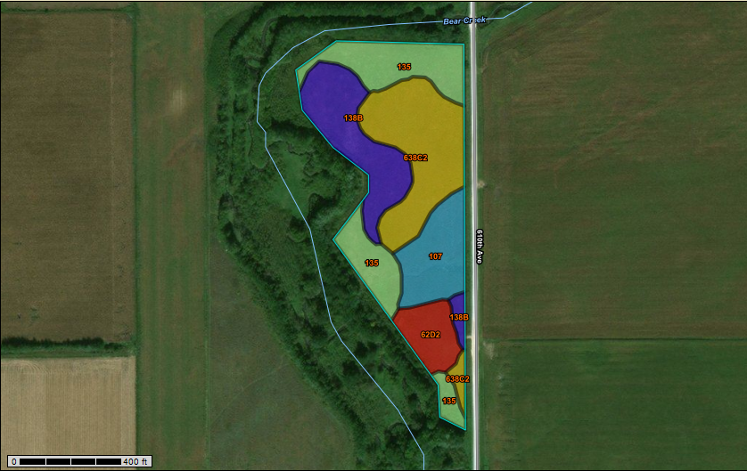

**Figure 1**. Screen shot from NRCS Web Soil Survey displaying example Iowa Corn Suitability Rating map. Data to be used for calculating opportunity cost for area of interest (CSR2).

|  |  |  |  |  |  |  |
| --- | --- | --- | --- | --- | --- | --- |
| **Table 3**: Soil summary by Map Unit for example 14 acre prairie area located in Story County, Iowa. | | | | |  |  |
| **Map unit** | **Map unit name** | **CSR2 Rating** | **Acres in AOI** | **Percent of AOI** |
| 638C2 | Clarion-Storden complex, 6 to 10% slopes, moderately eroded | 75 | 4.1 | 29.00% |
| 135 | Coland clay loam, 0 to 2 % slopes, occasionally flooded | 76 | 3.7 | 26.50% |
| 138B | Clarion loam, 2 to 6 % slopes | 89 | 3 | 21.60% |
| 107 | Webster clay loam, 0 to 2 % slopes | 86 | 2 | 14.40% |
| 62D2 | Storden loam, 10 to 16 % slopes, moderately eroded | 41 | 1.2 | 8.50% |
| Totals for Area of Interest (AOI) | |  | 14 | 100.00% |
|  | Area Weighted CSR2 | 76.98 |  |  |

Please note that direct, management, and opportunity costs of planting trees and or prairie can vary considerably from site to site and across time. Costs depend on initial site conditions (such as hydrology, soil, cropping history), weather, practice design (including variable tree stock and seed mix costs), management characteristics, farmer/landowner experience, and availability of technical or custom farm services. Likewise, opportunity costs vary year to year as land values change. As such, with cost assessments of this type, the cost estimates presented here serve as baseline numbers and are meant to be informative rather than prescriptive.

**Tree, Shrub, and Prairie Seed Mix Costs** Based on the soils present in the areas of interest, PT2 (1.0) has drop down menus for site-level soil appropriate tree/ shrub species selections and/or prairie seed mixes. The tree and shrub species recommendations based on soil groups are in accordance with the Iowa Department of Natural Resources (IDNR), Woodland Suitability Recommendations (IDNR, 2014: http://publications.iowa.gov/17411/). Compliance with IDNR species recommendations is required if landowners wish to participate in the Environmental Quality Incentive Program (EQIP) and receive cost share support. Likewise, for prairie plantings PT2 (1.0) includes a database that categorized soils (Iowa soils) based on soil moisture categories (e.g., wet, wet-mesic, mesic, dry-mesic, dry); pre-made seed mix options are based on these classifications. If the mix of soils present overlap across two different moisture classifications, all seed mix options are shown. Tree and seed costs are based on user selections.

For tree planting, users select the desire species and nursery stock size. The default costs for tree stock are based on a database of current (2019) regional nursery prices for various sizes of all tree and shrub stock (e.g., bare root stock to containerized). Likewise, default costs for pre-made prairie seed mixes across different soil conditions and conservation goals are based on a survey of regional seed company 2019/2020 catalog prices. Tables 4 and 5 below summarizes default costs. Alternatively, users can also input their own custom nursery or seed mix prices.

**Table 4:** Default tree and shrub nursery stock pricing. Data is a compilation of prices from five Iowa based tree nurseries; all prices per tree/shrub are based on 2020 pricing catalogs.

|  |  |  |  |  |  |  |
| --- | --- | --- | --- | --- | --- | --- |
| **Tree/Shrub** | Bareroot | Container (18"-24") | Container (2'- 3') | Container (3' - 4') | Container (4" - 5') | Container > 5' |
| Hybrid willow | $1.07 | $6.76 | $7.87 | $9.00 | $11.44 | $11.44 |
| Eastern Red Cedar | $1.46 | $17.42 | $26.00 | $36.40 | $46.80 | $62.40 |
| Conifers (average price across species) | $2.19 | $21.84 | $26.00 | $36.40 | $56.16 | $67.60 |
| Hardwoods (average price across species) | $1.40 | $8.84 | $33.80 | $36.40 | $46.80 | $62.40 |
| Shrubs (average price across species) | $1.38 | $8.32 | $12.48 | $14.56 | n/a | n/a |

**Table 5:** Prairieseed mix prices per soil types. 2019/2020 prices based on survey of regional seed dealers (n=5).

|  |  |  |
| --- | --- | --- |
| Hydric | Poorly, and very poorly-drained soils that typically have standing water for part or most of the growing season | |
|  | CP 21 Wet Buffer/ Filter Strip Mix | $ 130.00 |
|  | CP 25 Wet Rare and Declining Habitat 30/10 | $ 127.00 |
|  | CP 25 Wet Pollinator Habitat Statewide 10/30 | $ 239.00 |
|  | CP 42 Wet Pollinator Habitat | $ 187.80 |
|  | CP 43 Wet Prairie Strips | $ 185.00 |
| Wet-mesic | Somewhat poorly-drained lighter-colored clay soils |  |
|  | CP 21 Wet-Mesic Buffer/Filter Strip Mix | $ 130.00 |
|  | CP 25 Wet-Mesic Rare and Declining Habitat 30/10 | $ 115.00 |
|  | CP 42 Wet-Mesic Pollinator Habitat 10/30 | $ 200.00 |
|  | CP 43 Wet-mesic Prairie Strip | $ 163.00 |
| Mesic | Well drained and moderately well-drained, loamy soils |  |
|  | CP 21 Mesic Buffer/Filter Strip mix | $ 130.00 |
|  | CP 25 Mesic Rare and Declining Habitat Standard 30/10 | $ 145.00 |
|  | CP 25 Mesic Rare and Declining Habitat Economy 20/20 | $ 130.50 |
|  | CP 25 Mesic Rare and Declining Habitat Economy 30/10 | $ 88.33 |
|  | CP 25 Mesic Rare and Declining Habitat High Diversity 30/10 | $ 169.00 |
|  | CP 25 Mesic Rare and Declining Habitat w/o Switchgrass 30/10 | $ 115.00 |
|  | CP 42 Mesic Pollinator Habitat 10/30 | $ 239.75 |
|  | Monarch Mesic Pollinator 10/30 (EQIP) | $ 286.00 |
|  | Monarch Mesic w/ Little Bluestem (EQIP) | $ 472.00 |
|  | CP 42 Mesic Pollinator Habitat Standard | $ 212.50 |
|  | CP 42 Mesic Pollinator Habitat Economy | $ 140.00 |
|  | CP 43 Mesic Prairie Strips | $ 140.00 |
| Dry-mesic | Somewhat excessively drained glaciofluvial, eolian, and thick loess soils | |
|  | CP 21 Dry-Mesic Buffer/ Filter Strip | $ 130.00 |
|  | CP 25 Dry-Mesic Rare and Declining Habitat Tall grass 20/20 | $ 135.00 |
|  | CP 25 Dry-Mesic Rare and Declining Habitat Short Prairie 30/10 | $ 168.00 |
|  | CP 42 Dry-Mesic Pollinator Habitat 10/30 | $ 195.50 |
|  | CP 43 Dry-Mesic Prairie Strip | $ 135.00 |
| Xeric | Excessively drained sandy or gravelly soils and shallow loam soils on steep slopes and ridges |  |
|  | CP 25 Dry Rare and Declining Habitat Tall grass 20/20 | $ 135.00 |
|  | CP 25 Dry Rare and Declining Habitat Short Prairie 30/10 | $ 168.00 |
|  | CP 42 Dry Pollinator Habitat 10/30 | $ 195.50 |
|  | CP 43 Dry Prairie Strip | $ 135.00 |
| Notes: | 20/20 is a mix with 20 grass seeds and 20 wildflower seeds per square foot | | |
|  | 10/30 is a mix with 10 grass seeds and 30 wildflower seeds per square foot | | |
|  | 30/10 is a mix with 30 grass seeds and 10 wildflower seeds per square foot | | |

**Conservation program parameters and payment schedules for 2020**

There are a number of different Federal, state, or non-governmental organization conservation programs that landowners can utilize to obtain catered technical planning assistance and help offset direct and opportunity costs of planting trees and or prairie.

For prairie systems, as part of the overall financial assessment, the PT2 1.0 includes the financial effects of two USDA Conservation Reserve Program options, one is the CP 42 Pollinator Habitat, the other is the new CP 43 Prairie Strips program. Payment schedules are as follows:

[**CP 42 Pollinator Habitat (Conservation Reserve Program)**](https://www.fsa.usda.gov/Assets/USDA-FSA-Public/usdafiles/FactSheets/2019/crp_continuous_enrollment_period-fact_sheet.pdf)

The CP-42 is designed to provide habitat for native pollinator species and honey bees. This is a program paid by the USDA Farm Service Agency and facilitated by the USDA NRCS. Landowners receive: 1) Sign-up Incentive Payment (SIP) equal to 32.5% of first full year’s annual rental payment, plus a 5% Practice Incentive Payment (PIP); 2) Annual 90% rental payments based on weighted rental rates; and 3) Cost share payment covering up to 50 percent of the eligible cost of establishing the practice.

PT2 1.0 assumes a 15 year contracted period as part of the continuous signup program (as such, this would account for one and a half ten-year contracts).

[**CP 43 Prairie Strips (Conservation Reserve Program)**](https://www.fsa.usda.gov/Assets/USDA-FSA-Public/usdafiles/FactSheets/2019/crp_clear_initiative_prairie_strip_practice-fact_sheet.pdf)

The CP-43 is designed to facilitate the use of strips of prairie panted on the contours or toe slopes of crop fields to intercept run off, increase infiltration and water storage, and create pollinator habitat. This is a program paid by the USDA Farm Service Agency and facilitated by the USDA NRCS. Landowners receive: 1) Sign-up Incentive Payment (SIP) equal to 32.5% of first full year’s annual rental payment, plus a 5% Practice Incentive Payment (PIP); 2) Annual 90% rental payments based on weighted rental rates; and 3) Cost share payment covering up to 50 percent of the eligible cost of establishing the practice. PT2 1.0 assumes a 15 year contracted period as part of the continuous signup program (as such, this would account for one and half ten-year contracts).

For tree systems, as part of the overall financial assessment, the PT2 1.0 includes the financial effects of two Environmental Quality Incentive Program (EQIP) options. EQIP is a program administered and paid for by the USDA NRCS. These are one-time payments that occur in the first year of the practice. PT2 1.0 chooses and combines the program and payment parameters that best approximates the user designed tree planting. Actual NRCS tree planting plans and payment schedules will vary from project to project. PT2 1.0 assumes that landowner would at minimum receive payments for site preparation (CP 490) and some payment for nursery stock (CP 612 for tree plantations, or CP 380 for designated windbreak systems. Optional irrigation program payments can be selected by user. Other EQIP payments may be available for: weed management, planting, mulching, and various other establishment considerations.

**Tree Planting EQIP Programs**

For non-windbreak tree systems (e.g., conservation plantings to control erosion or protect water quality, habitat improvement, plantations to promote natural regeneration, carbon storage), PT2 1.0 will select CP 490 for site preparation and the CP 612 tree purchase and planting program that best approximates the user selected planting design. If irrigation is selected by user, the CP 441 (micro-irrigation) program is also included.

The following are the various CP programs and payment parameters. All data is based on the [2020 Iowa NRCS EQIP payment schedule](https://www.nrcs.usda.gov/wps/portal/nrcs/detail/national/programs/financial/?cid=nrcseprd1328237).

|  |  |  |
| --- | --- | --- |
| **(**[**Conservation Practice 490: Site preparation**](https://www.nrcs.usda.gov/wps/portal/nrcs/detail/national/technical/nra/?cid=nrcs144p2_027160)**)** | | |
| Site preparation (light mechanical and chemical weed control) | acre | $138.26 |

**Plus**

|  |  |  |
| --- | --- | --- |
| **(**[**Conservation practice 612: Tree and shrub establishment**](https://www.nrcs.usda.gov/wps/portal/nrcs/detail/national/soils/health/?cid=nrcs144p2_027187)**)** | | |
| Hardwood establishment, bareroot | acre | $588.26 |
| Conifer establishment, bareroot | acre | $607.88 |
| Tree establishment, pasture conversion | acre | $370.13 |

**If irrigation is selected by PT2 1.0 user:**

|  |  |  |
| --- | --- | --- |
| **(**[**CP 441: Irrigation System**](https://www.google.com/url?sa=t&rct=j&q=&esrc=s&source=web&cd=&ved=2ahUKEwit0aTbw-TqAhXCZc0KHfmtBiwQFjABegQICxAE&url=https%3A%2F%2Fwww.nrcs.usda.gov%2Fwps%2FPA_NRCSConsumption%2Fdownload%3Fcid%3Dnrcseprd340699%26ext%3Dpdf&usg=AOvVaw01ecQpLO5vLQsoJUOBAMUl)**)** | | |
| Micro-irrigation Trees and Shrubs | Linear ft | $0.35 |

**For user-selected windbreak systems**, PT2 1.0 will select CP 490 for site preparation, and the CP 380 (windbreak establishment) program that best approximates the windbreak design (in terms of species selection and number of tree rows). If irrigation is selected by user, the CP 441 (micro-irrigation) program is also included.

|  |  |  |
| --- | --- | --- |
| **(**[**Conservation practice 380: Windbreak establishment**](https://www.nrcs.usda.gov/wps/portal/nrcs/detail/?cid=nrcs144p2_027140)**)**  **If no irrigation:** | | |
| 1 - 2 row windbreak, bareroot seedlings | linear ft | $0.36 |
| 1 - 2 row windbreak, container trees (any size) | linear ft | $0.60 |
| 3 or more row windbreak, bareroot seedlings | linear ft | $0.94 |
| 3 or more row windbreak, containerized plant stock (any size) | linear ft | $3.43 |

|  |  |  |
| --- | --- | --- |
| **(**[**Conservation practice 380: Windbreak establishment**](https://www.nrcs.usda.gov/wps/portal/nrcs/detail/?cid=nrcs144p2_027140)**)**  **With irrigation:** | | |
| 1 - 2 row windbreak, bareroot trees w/irrigation | linear ft | $0.47 |
| 1 - 2 row windbreak, containerized plant stock w/irrigation | linear ft | $0.60 |
| 3 or more row windbreak, bareroot w/irrigation | linear ft | $2.72 |
| 3 or more row windbreak, container (any size) w/irrigation | linear ft | $5.22 |

**About the software** The Prairie and Tree Planting Tool (PT2 1.0) is a modern application built with front-end tools such as React and Mapbox. The design of the tool focused on ease-of-use and portability. Mapbox's mapbox-gl-js library was used to build all interactive map features, and the Mapbox service free-tier was used to host and serve SSURGO soil data. All other data layers are served from ISU GIS department endpoints. The application is also backend-less, meaning all assets are static and there are no servers or databases to secure and maintain, and no user privacy considerations. All data is retained on the front-end on the user's device, and not saved on any hosted servers and databases. To share data, users simply download a JSON file and email it to the recipient who can then load it into the app on their device. To port this application for other use, simply fork the Github repository and make changes to the Planting Forms and Report logic as needed.

To customize this project for your own use, simply download a zip file of the codebase, or use the git command line tool to clone the repository. You can also fork the repository for your own use by clicking the "Fork" icon in the Github interface when viewing the repo. You will have to provide your own Mapbox-hosted data layers. To develop this project, working knowledge of the following may be required:

* HTML
* CSS
* CSS precompilers such as SASS
* JavaScript
* react.js (a JavaScript framework)
* mapbox-gl-js (a JavaScript library for working with interactive maps using Mapbox)
* Webpack (for compiling and building the project)

**Appendix A: Soil productivity and land rent data for Iowa**

**Table A1.** Iowa Counties and average rent per Corn Suitability Rating 2 point. Data from Plastina et al. 2019. Data is used to calculate area weighted opportunity costs.



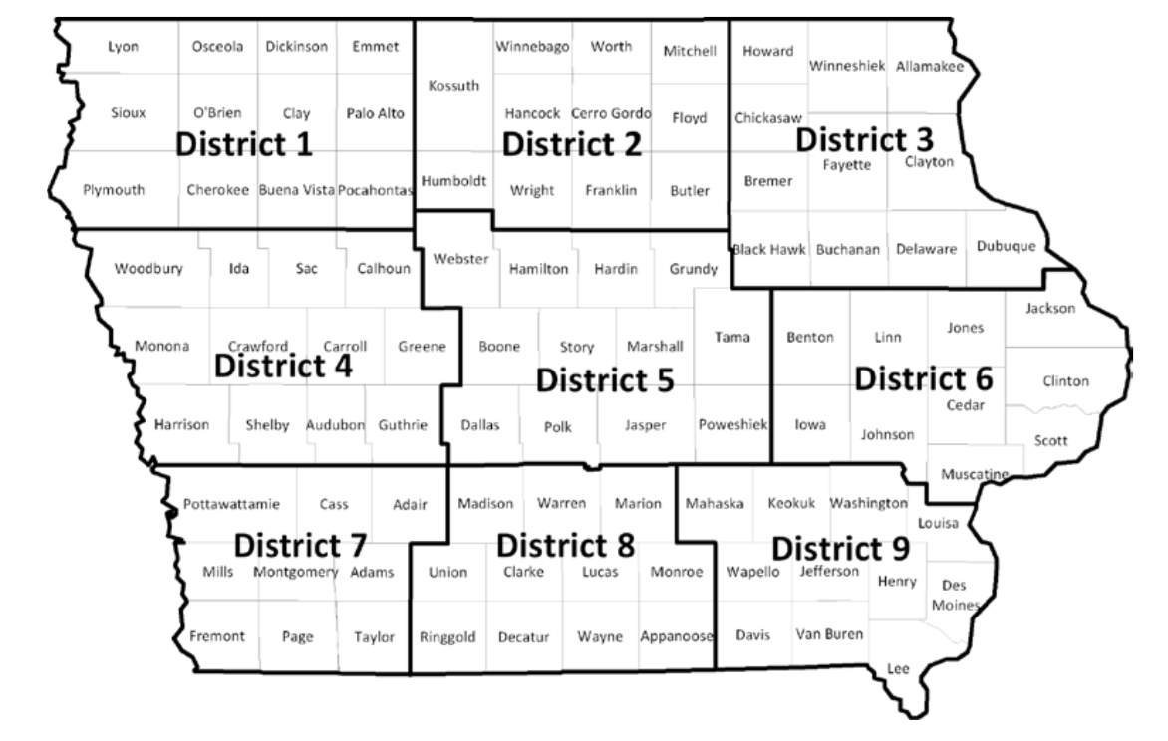

**Figure A1.** Iowa counties delineated into reporting districts for land rent assessment, Plastina et al. 2019.

**Table A2.** Average rent per Corn Suitability Rating 2 point by district. Data from Plastina et al. 2019. Data is used to calculate area weighted opportunity costs tree or prairie plantings that take crop land out of production.

|  |  |
| --- | --- |
| District | Average rent per CSR2 point |
| D1 | $2.65 |
| D2 | $2.63 |
| D3 | $2.99 |
| D4 | $3.04 |
| D5 | $2.72 |
| D6 | $2.85 |
| D7 | $2.67 |
| D8 | $2.28 |
| D9 | $2.64 |

**References**

Brandle JR, Hodges L, Tyndall JC, Sudmeyer RA. (2009) [Windbreak Practices. North American Agroforestry: An Integrated Science and Practice – Second edition.](https://dl.sciencesocieties.org/publications/books/tocs/acsesspublicati/northamericanag) American Society of Agronomy, Inc. Madison, Wisconsin.

Erickson, K.W., C.B. Moss, and A.K. Mishra. 2004. [Rates of return in the farm and nonfarm sectors: How do they compare?](https://pubag.nal.usda.gov/catalog/38718) *Journal of Agricultural Applied Economics*. 32:789–795.

Groh, T. A., Isenhart, T. M., & Schultz, R. C. (2020). [Long-term nitrate removal in three riparian buffers: 21 years of data from the Bear Creek watershed in central Iowa](https://www.sciencedirect.com/science/article/pii/S0048969720336354), USA. *Science of The Total Environment*, 140114.

Iowa Department of Natural Resources (2014) 2014 Iowa Woodland Suitability Recommendations, February 6, 2014. Available at: <http://publications.iowa.gov/17411/>

Manatt, R. K., Hallam, A., Schulte, L. A., Heaton, E. A., Gunther, T., Hall, R. B., & Moore, K. J. (2013). [Farm-scale costs and returns for second generation bioenergy cropping systems in the US Corn Belt](https://iopscience.iop.org/article/10.1088/1748-9326/8/3/035037/meta). *Environmental Research Letters*, *8*(3), 035037.

Plastina, A., Johanns, A., & Welter, C. (2020). [2020 Iowa farm Custom rate Survey](https://store.extension.iastate.edu/product/2020-Iowa-Farm-Custom-Rate-Survey). Ag Decision Maker, Iowa State University. File A3-10.

Plastina, A., Johanns, A., & Welter, C. (2019). [Cash Rental Rates for Iowa 2019 Survey](https://www.extension.iastate.edu/agdm/wholefarm/html/c2-10.html). Ag Decision Maker, Iowa State University. File C2-10. FM 1851, Revised May 2019.

Schulte, L. A., MacDonald, A. L., Niemi, J. B., & Helmers, M. J. (2016). [Prairie strips as a mechanism to promote land sharing by birds in industrial agricultural landscapes](https://www.researchgate.net/publication/290508097_Prairie_strips_as_a_mechanism_to_promote_land_sharing_by_birds_in_industrial_agricultural_landscapes). *Agriculture, Ecosystems & Environment*, *220*, 55-63.

Soil Survey Staff, Natural Resources Conservation Service, United States Department of Agriculture. Soil Survey Geographic (SSURGO) Database. Available online at [https://sdmdataaccess.sc.egov.usda.gov](https://sdmdataaccess.sc.egov.usda.gov?referrer=Citation.htm-SSURGOLink).

Tyndall JC, Schulte L, Liebman M, Helmers M. (2013) [Field-Level Financial Assessment of Contour Prairie Strips for Environmental Quality Enhancement.](https://link.springer.com/article/10.1007/s00267-013-0106-9) Environmental Management. 52(3): 736-747.

USDA Natural Resource Conservation Service (2013). NB 200-18-1 ECN - Normalized Prices and Discount Rate for FY 2018 Water Resources Planning and Evaluation.